**Using Hyper-terminal to communicate with DE1 Board**

* Install the Hyper-terminal software on your PC/Laptop.
* Plug the USB to RS232 converter “dongle” supplied your instructor into your PC/Laptop and also into the DE1 Serial Port (DB9 connector top right of the DE1 board). Windows should install the driver automatically.
* Start Hyper-terminal – The following screen appears – Type de1 into the Connection Description (the name is not important but you have to give one). Click OK

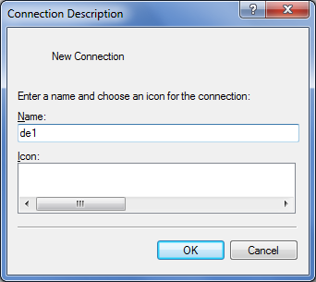

The following will appear asking you to connect via a “virtual” COM3 serial port on your PC. If you don’t get this and it asks for a **TCP/IP (Winsock)** connection it is because you either don’t have your USB-RS232 dongle plugged in, or the driver is not working.

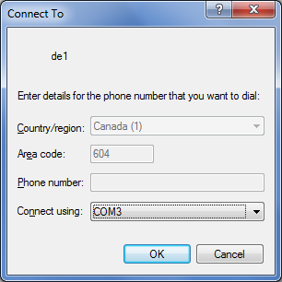

Click **OK** – The following will appear

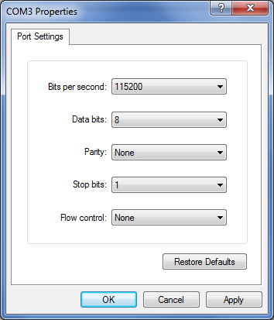

Set **COM3** Port settings as shown above – Click **OK**

You should have the following virtual terminal connection to the DE1 board which allows you to communicate with it using your PC/Keyboard.

If you have programmed (flashed or downloaded) your DE1 with a working 68000 system, you should see a ‘**#**’ prompt when you press the rest on the DE1 (blue push button 1 – bottom right).

If you hit return you will see that you are communicating with a debug monitor that allows you to load, run, debug and program into flash memory a program that you have/will downloaded

